Welcome to
Garden Club Gossip & Glee
Your online version of the
MILLBROOK & AREA GARDEN CLUB

The mysterious spirit of nature – Whoooo’s there in this photo? - often a Hallowe’en symbol.

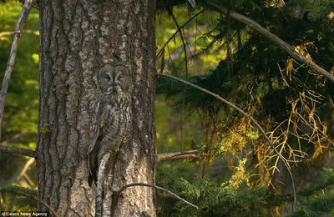

May Jack-o-lanterns burning bright
Of soft and golden hue
Pierce through the future's veil and show
What fate now holds for you.
By goblins of the cornfield stark
By witches dancing on the green
By pumpkins grinning in the dark
I wish you luck this Hallowe’en.
~Postcard from the early 1900s

Little Known Pumpkin Facts – (from the Farmer’s Almanac)
1. The word ‘pumpkin’ comes from the Greek word, pepon, which means a “large melon.”
2. Pumpkins originated in Central America.
3. Pumpkins are actually a fruit. Many people think it should be our national fruit.
4. Pumpkin is also a squash; a member of Cucurbita family.
5. The yellow-orange flowers that bloom on the pumpkin vine are edible.
6. Pumpkin seeds taste great roasted and contain medicinal properties.
7. Native Americans grew and ate pumpkins and their seeds long before the Pilgrims reached this continent. Pilgrims learned how to grow and prepare pumpkins from the Native Americans.
8. Pumpkin was most likely served at the first Thanksgiving feast celebrated by the Pilgrims and the Native Americans in 1621.
9. The earliest pumpkin pie made in America was quite different than the pumpkin pie we enjoy today. Pilgrims and early settlers made pumpkin pie by hollowing out a pumpkin, filling the shell with milk, honey and spices and baking it.
10. Early settlers dried pumpkins shells, cut it into strips and wove it into mats.
11. Pumpkin has been prepared in a variety of ways from soups to stews to desserts since the immigration of the first European settlers.
12. The ‘Pumpkin Capital of the World’ is Morton, Illinois. Home of Libby’s pumpkin industry.
13. The state of Illinois grows the most pumpkins. It harvests about 12,300 acres of pumpkins annually.
14. The latest U.S. record (2019) for the largest pumpkin ever grown weighed in at 2,517.5 pounds by Karl Haist of Clarence Center, New York.
15. Pumpkins were once considered a remedy for freckles and snakebites.
16. Natural medicine practitioners have proven that consuming pumpkin seeds reduces the risk of prostate disorders in men.

Devilish Black Elderberries and Friends
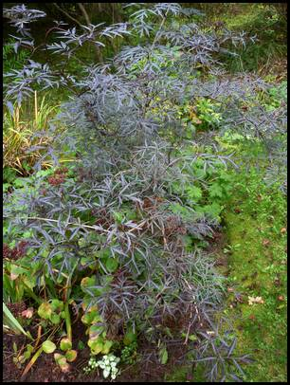
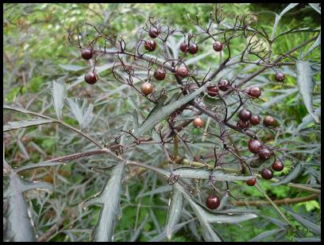

Fruit and striking deep purple-red almost black foliage of Black Lace elderberry (photo by author)
A suitable addition for a dark Hallowe’en night, “Black Lace” Sambucus nigra is a European elderberry cultivar. As its namesake “Black Lace’ indicates, it produces deeply lobed lacy almost black (a very dark purple) leaves. The shrub also produces pretty, light-pink, fragrant (lemon-scented) flowers, which appear in flat-topped clusters in mid to late summer. These flowers produce richly black, glossy berries in the fall.

The black berries are edible and are high in vitamin C. Technically, “Black Lace” elderberry is self-pollinating, but planting another cultivar nearby helps for increased pollination and fruit production.
However, if one wants to harvest elderberries for food and drink production, the American elderberry (Sambucus canadensis) which is a heavier berry producer is a better choice than “Black Lace”. The value of “Black Lace” elderberry, aside that it will attract birds and insect pollinators, is its dark colour which can be used visually to great effect by creating dramatic contrast and interest in the garden especially when planted near or among white flowering or silver foliaged plants.

This shrub which can grow 1.8 to 2.4 metres (6 to 8 feet) tall and about as wide likes sunny conditions but will tolerate partial shade. It will produce more flowers and more attractive foliage color if grown in full sun. “Black Lace” elderberry bush tolerates clay soil types and wetter conditions better than many shrubs because in its natural habitat elderberries are often found near wetlands.

It blooms and fruits on new growth which means if any pruning is to be done, it should be done in late winter or early spring. When woody stems of the plant get older, they become weaker and less attractive, so removing these older stems will direct more energy into the newer, more attractive stems. “Black Lace” elderberry can spread via suckers. These suckers can be pruned out to keep the plant from spreading, or - it can be allowed to expand.

Like all elderberries, “Black Lace” elderberry is vulnerable to aphids, borers, and spider mites. Borers are problematic in the Moraine garden. Elderberry Borer Beetles which are bright yellow orange and metallic blue are native to eastern and central North America. Eggs are laid on elderberry bark, branches and leaves. Hatched larvae bore their way into the center of the stems to feed on the plant's juices killing the branch. They leave behind frass (insect excrement) that resembles wood shavings. As they mature, the larvae continue to bore down to the roots of the plant where they will pupate. It takes approximately two years for the larvae to develop into adults. Borers can take down an entire shrub within a year.

However, elderberries have a created a chemical defense through manufacturing potent cyanogenic glycosides, toxic compounds that are believed to be passed along from larvae to adults. A taste of these noxious chemicals by the yellow/orange and blue bugs sometimes repels them. The black lace elderberry in the garden which almost succumbed to borers must have created this chemical defense, because they no longer seem to be an issue.

“Black Lace” elderberry, like all elderberries, is also susceptible to cankers, leaf spots, and powdery mildew which are all best addressed through prevention ensuring there is proper spacing to promote good air circulation, watering at soil level, and keeping mulch six inches away from the main stems of the shrub.

The North American native American elderberry, Sambucus canadensis sometimes known as the common elderberry, is a deciduous shrub with bright white flowers and small, dark berries and lush green leaves. Black elderberry fruits can be eaten and cooked with, but should only be consumed when they are fully ripened and dark black which is usually some time in September.
This fast growing shrub can reach heights of up to 3.6 metres (12 feet) with a spread of about 1.8 metres (6 feet). Best planted in early spring after the final frost, American elderberry is a moderately-fast growing shrub. Like “Black Lace”, sunny and rich moist conditions suit it best. It an also be pruned during the winter.

There is another native elderberry called red elderberry Sambucus racemosa - also a deciduous suckering shrub similar in appearance to common elderberry except red berries are borne in late spring/early summer. Unlike the black fruits of the native and European cultivars which are edible, the sour red berries which are enjoyed by some wildlife are toxic to humans and not edible. Some experts state that cooking can remove the toxins but other experts recommend avoiding even cooked red elderberries which contain a cyanide-inducing glycoside. Eating a sufficient quantity of these cyanide-inducing glycosides can cause a toxic buildup of cyanide in the body and make you quite ill including nausea, vomiting, and diarrhea.
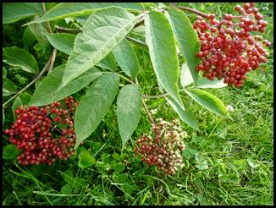

Red spring-bearing elderberries (photo by author)

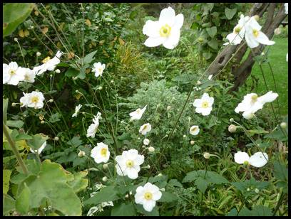
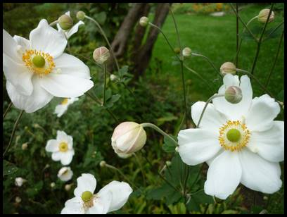
Heavenly Honorine Jobert

Photos by author taken October 23 -these beauties started to bloom late September and have not stopped since
Many a gardener is familiar with the late summer blooming purple/pink Japanese anemone which isn’t Japanese but Chinese in origin named Anemone hupehensis, after its native site in the Hupeh province in eastern China. Some have a love/hate relationship with this plant - love the flowers but don’t like its tendency to spread and crowd out other plants.

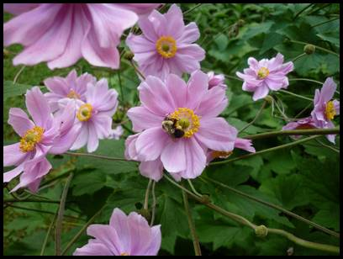

Pretty and loved especially by bumblebees – but sometimes can be a bit of a garden thug – photo by author

For those who enjoy the flowers but not the size and spread, there is a dwarf version that is also a late bloomer but only grows about 25 cm tall (10 inches)
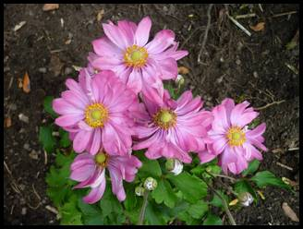

Dwarf fall blooming anemone – photo by author

However, there is Honorine Jorbet which not only blooms much later, and bears very bright white flowers, it is not a big spreader.

The cultivar ‘Honorine Jobert’, in the buttercup family (Ranunculaceae) is an old garden hybrid which was discovered in Verdun, France in 1858. This hybrid, also called A. x hybrida ‘Alba’, was a “sport” of the pale pink Anemone x hybrida, which was a cross between A. hupehensis var. japonica and A. vitifolium. A ‘sport’ also called ‘lusus,’ is a part of a plant that shows morphological differences from the rest of the plant – a genetic mutation. In this case pure white flowers instead of purple or pink were produced.

In England it was selected as the Perennial Plant Association’s Perennial of the Year 2016 and was awarded the RHS Award of Garden Merit in 1993. It was rated ‘good’ (4 of 5 stars) in a plant evaluation study by the Chicago Botanic Garden.

It is a low-maintenance plant, with a fibrous-rooted woody base that forms neat, dense, compact mounds of foliage. The glossy toothed palmate basal foliage only grows 12-18 inches tall, but when in bloom the wiry stems with flowers rise up 90 to 120 cm (3-4 feet) tall or taller.

The flowers open from round, pink-washed outer buds into groups of single to semi-double, open-faced flower brilliant white petals with numerous bright yellow stamens in a ring surrounding a chartreuse centre. ‘Honorine Jobert’ blooms over 5-8 weeks from late summer into early fall. The flowers routinely bloom well past first frost and are enjoyed by bees looking for a last minute meal. The blooms are followed by rounded seed heads at the end of the stems, although they rarely produce seeds. It is slow to establish – verified in the Moraine garden where it has taken a number of years to create a small colony. It spreads by shallow creeping, wiry black rhizomes. ‘Honorine Jobert’ can be propagated by division in It is late to emerge in spring, so sometimes is mistakenly pulled out as being dead and as pointed out may be slow to establish.

This cultivar of Japanese anemone grows best in full sun to part shade in evenly moist but well-drained soil rich in organic matter and can also thrive in clay soils; often found in our area. It does not tolerate dry soil, but also will not tolerate wet soils, especially in early spring. The plants do not have any serious insect or disease problems, although sometimes slugs, and flea beetles may attack them. Deer or rabbits don’t find them to be delicious. Note: Contact with the sap may irritate the skin in some people.

If you have any tips, photos, garden stories, questions or information you wish to share or topics you would like covered - please contact our communications coordinator.

