Welcome to
Garden Club Gossip & Glee
Your online version of the
MILLBROOK & AREA GARDEN CLUB

More on Trees

For those with a woodlot and especially a woodlot with an older tree plantation, the Ontario Woodlot Association in collaboration with the Kawartha Land Trust, residents in nearby Manvers Township have started a local Forestry Cooperative for several reasons:
• Prevent their plantations from collapsing, and generate modest profit
• Position themselves to take advantage of carbon credits
• Transition their forests to more biodiverse native hardwood forests
• Explore alternative revenue sources collectively such as eco-tourism and explore other social benefits such as wildlife corridors and trails
• Reduce the expense of working with professional foresters and biologists by working collectively.

Plantations in southern Ontario were established originally as a way to rehabilitate previously deforested land. In many cases, these plantations are not being managed (thinned) and this can result in complete collapse of the forest because it becomes too dense to support natural regeneration. Our new Community Forestry Co-operative pilots aim to provide an affordable means for landowners to take care of their forests, so they evolve into more biodiverse systems that all can enjoy.
Please contact info@ontariowoodlot.com or call 613 713 1525 to inquire about joining.

An interesting 5 minute Youtube video on an existing co-operative can be found in this link:

https://www.youtube.com/watch?v=NQxTT3z87eY&feature=youtu.be
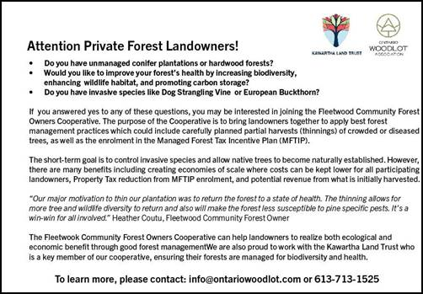

(Thanks to Andy for the notice)

More Trees Please …. According to a consultant report coming before Cavan Monaghan Council, it is anticipated there will be yet another subdivision application for another 192 residential units (Duke Street subdivision) on the wooded lands in Millbrook behind existing houses along the south side of King Street East and just west and along County Road 10 – which, if approved, will mean the loss of even more trees.

And more trees please for the young ones and ones young at heart –

According to an estimate from the David Suzuki Foundation, the average North American child spends less than 30 minutes playing outside each day, and more than seven hours in front of a screen. What if these screens could promote outdoor exploration? Tree Tap Adventure is a mobile app that encourages players to get outside and explore their surroundings.
Through this game, players can plant, grow and design their own virtual forest. By exploring different habitats, players can also meet the animals that are found in these environments. The game utilizes augmented reality, where the real world is enhanced through a screen. Players can become different forest creatures or see their designs come to life outdoors.
Not only does Tree Tap Adventure get players outdoors and exploring, it will also help to plant real trees and support forest education! Part of their mission is to protect and regenerate forests around the world so that ecosystems can continue to support all of us. By playing the game, players will be supporting Forests Ontario’s tree planting programs through a donation made by Oak AR Production. Let’s get outside!
Find out more at https://www.treetapadventure.com/

Earthworms are Invasive and Destructive to Woodlands!

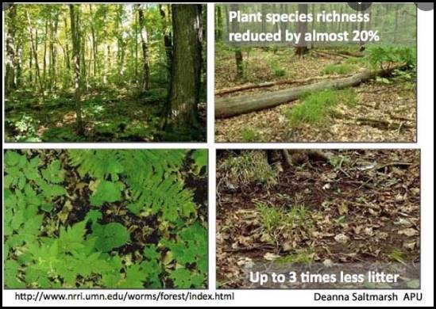

Earthworms, which often gardeners rejoice at seeing in their soil, are not native to most of North America! It is thought that earthworms which might have once inhabited our region were killed off when a vast ice sheet covered the northern third of North America about 10,000 years ago. The Oak Ridges Moraine that covers a large portion of our region is the result of the soil being scraped and heaped into large hills as the glacial ice retreated.

Before the invasion of earthworms, microbes and other soil-dwelling organisms such as mites, nematodes, millipedes and fungi broke own organic matter in our forests. These usually microscopic creatures turned leaves and wood bits into soil and in return freed up the nutrients for trees and undergrowth in a very slow process.

While earthworms in the garden might be valued, when earthworms move into our forests, their activities rapidly changes ecosystems because instead of a slow centuries-old process, earthworms devour leaf litter very quickly. Any gardener who has piled leaves onto garden beds in the fall, know that they are gone by the next summer season. Concerned scientists have noticed this quick debris consumption by earthworms where they have taken hold in woodlands has created changes in the ph of soils as well as changes in the soil texture and nutrient levels creating an alien soil environment which our native forest plants - trees, shrubs and groundcover plants are not adapted to.

More recently, several species of Asian earthworms have made their way to the continent, and they have soil scientists particularly concerned. Originally from Korea and Japan, they are known as "jumping worms," "snake worms," or "crazy worms" — named for their distinctive thrashing when disturbed. They are ravaging soils throughout the U.S., and have crossed the border into Canada.
There are fears that jumping worms pose an even greater threat than their European predecessors. Jumping worms have many of the same effects on a woodland as earthworms we are familiar with, except that they grow larger, recycle nutrients even faster and exist in dense colonies, sometimes numbering more than 100 individuals per square metre of ground. Jumping worms are known to quickly churn the top layer of soil, turning it into something that resembles coffee grounds from all the worm droppings.

Thanks to Joan for the notice of this new ‘invasive’ … and don’t dump any soil from your garden into a nearby woodland!

Autumn Giants

Helianthus salicifolius & Coreopsis tripteris
The following two show-stopping native plants are welcome late summer/ autumn bloomers in the Moraine garden and the willow-leaf sunflower is just finishing blooming now. Both of these native plants provide important food sources for a variety of insects late in the season when many other flowering food sources have disappeared. Unfortunately neither are found in many nurseries.
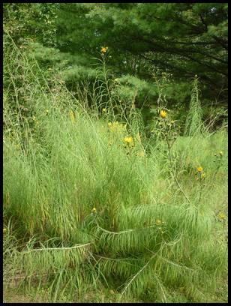
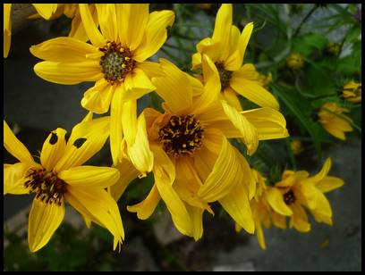

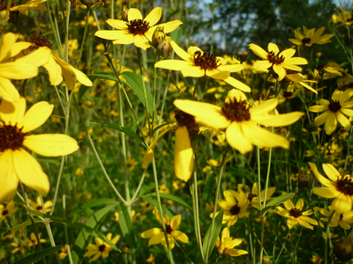
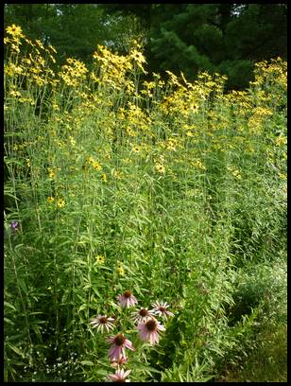

Close-up of willow-leaf sunflowers, their long ferny stems - close-up of the flowers of giant tickseed and their tall erect stems (photo by author)

Giant willow-leaf sunflower

Helianthus salicifolius , commonly called willow-leaved sunflower, is native to the Eastern United States. The genus name Helianthus comes from the Greek words helios meaning ‘sun’ and anthos meaning ‘flower’. The specific epithet “salicifolius” means with leaves like Salix (willow).
This giant North American native plant features clusters (branched panicles) of approximately 1 to 2 cm (0.4 to 0.8 in) wide sunflowers with bright yellow rays and dark brown center disks. These flower clusters appear at the very tip of very long wand-like whitish-green stems typically growing 1.8 metres (6 feet tall) or taller! A planting on the south side of the house in the Moraine garden bears stems that extend over 3 metres (10 feet). It bears narrow, drooping, willow-like, pale green leaves. This imposing plant makes for an unusual specimen in the sunny border but it needs a lot of space. It is visually appealing to see the long stems and fronds wave in the slightest breeze.
It is easily grown in average, medium, well-drained soil in full sun and it is tolerant of wide range of soil conditions. Deer tend to avoid this plant, but late migratory and non-migratory birds do like to feast on the seeds.
This wildflower does spreads over time by creeping rhizomes to form dense colonies so, unless in an wide open space, it is recommended this plant be divided every 3-4 years to control it spread.
Prairie Tickseed

Coreopsis tripteris was formerly known as Bidens tripteris. It is commonly known as Prairie Tickseed because it is thought the seeds look like ticks. Common names also include tall tickseed, tall coreopsis and Atlantic coreopsis. It is a wide-spread North American species, found naturally growing in several parts of Ontario. It belongs to the aster family, Asteraceae.

The genus name Coreopsis comes from the Greek words koris meaning "bug" and opsis meaning "like" in reference to the shape of the seed which resembles a bug or tick. The specific epithet “tripetris” refers to the leaves being divided into three narrow lance-shaped segments.

This very tall late summer bloomer can be grown in average, dry to medium, well-drained soils in full sun. It tolerates heat and drought. In the gravelly Moraine garden soil, these plants reach a height about 1.8 metres (6 feet tall) but in medium wet soils with consistent moisture they tend to be taller and fuller. The leaves are mostly divided into 3 leaflets (thus the suitable description ‘tripteris’) which are smooth-edged to lobed. The flower heads have yellow ray florets about 1 to 2 cm (0.4 to 0.8 in) long. The center of the head has many disc florets in shades of reddish brown to purplish.

This late summer bloomer sometimes will re-bloom in October if the first flowers are dead-headed right after blooming. Prompt deadheading of spent flowers not only may encourage additional bloom, it prevents any unwanted self-seeding. This plant freely self-seeds which might not be welcome in a small garden but perhaps welcome in a field. In optimum growing conditions will naturalize to form large colonies. If grown in gardens as a back border division may be needed every 2-3 years to maintain robustness.

If you have any tips, photos, garden stories, questions or information you wish to share or topics you would like covered - please contact our communications coordinator.

