Welcome to
Garden Club Gossip & Glee
Your online version of the
MILLBROOK & AREA GARDEN CLUB

“To plant a garden is to believe in tomorrow” – Audrey Hepburn

What better way to ‘believe in tomorrow’ than bringing plants to our plant sale or purchase plants on September 26th from 10 am to 1 pm at the Old Millbrook School. Previously, labels were made available beforehand at a meeting, but this time, it will not be possible. So, those bringing plants, please label them in any fashion your imagination takes you☺ As indicated in the notice below, those bringing plants, please come at 9:30 or even earlier that day because all the plants have to be priced beforehand. Also note… this time of year as perennial plants prepare to go dormant, some won’t look their best, but this does not mean they are not healthy!

Calling all Gardeners!!

Plants wanted for the Fall Plant Sale on Sunday Sept. 26th, 2021
Where? At the Farmer’s Market, Old Millbrook School
What time? We will be setting up the plants at 9:30 A.M.

Plant Sale: 10 A.M. – 1 P.M.

Now that your perennials, grasses, and shrubs have flourished and flowered over the summer, perhaps some need dividing, or some you no longer want. Pot them up and bring them to the Plant Sale. An information label with plant name, colour, sun or shade, size, and bloom time would be helpful.
All donations gratefully received!!
This is one of your Garden Club’s major fundraisers. Thank you for helping!
From Your Millbrook & Area Garden Club Plant Sale Committee

For those interested in seeing a couple of lovely Port Hope fall gardens, meet experts and get tips on how to prepare your garden for the winter, the Port Hope Library is sponsoring this fundraiser. Tickets are limited.

Bad, Bad Bird and Bat Killing Burdock!

Anyone who has gone on fall hikes or walked their dog or rode their horse are familiar with the terrible sticky bur heads of burdock. They are almost impossible to remove from clothing and fur.
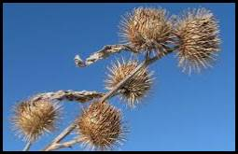

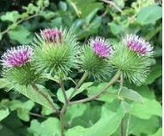
But what some might not realize, is that these foreign invasive big weedy plants are responsible for the slow agonizing death of 1000s of birds and bats each year that become entangled and stuck to the Velcro-like seed heads. Burdock can reach heights over 2 metres ( 6 foot tall), with large heart shaped basal leaves similar to rhubarb and stalks of spiky purple flowers that result in the sticky seed heads, often known as ‘cockleburs’. In dense patches, the leaves crowd out all other native plants destroying valuable wildlife habitat.
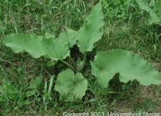
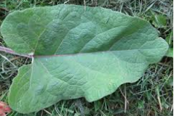
Burdock is a tenacious weed with a massive taproot that does not respond well to herbicide control. But, it is a biennial, so it can be controlled by cutting off the flowers and seed heads into bags and then into the garbage – not the compost pile!
Below… some interesting but sad articles on the toll this weed is having on our already diminishing songbird and bat populations.

Birds & Burdock | Naturally Curious with Mary Holland (wordpress.com)

Caring for and Healing the Earth (earthcaretaker.com)
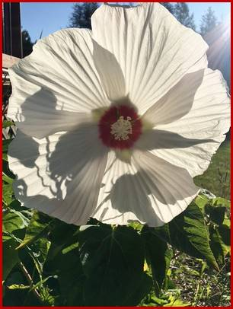
Swamp Mallow – Hardy Hibiscus
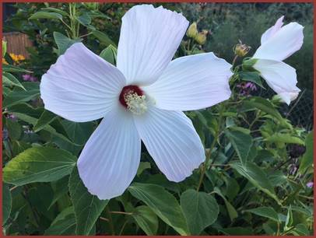

Photos by garden club member

In late summer, nurseries, garden centres and even grocery stores feature these dramatic large flowering perennials that come in blooms of white, pink, red, lavender, rose and peach as well as bi-colored and leaves ranging from green to fancy cut-leaf bronze. Gardeners might be surprised to know this exotic late summer bloomer actually has its origins in a native plant that is a species at risk in Ontario.

In Ontario, natural habitat of the pink flowering Hibiscus moscheutos, commonly known as hardy hibiscus or swamp rose mallow is restricted to shoreline marshes in the Carolinian regions of the Great Lakes, Lake St. Clair and along the St. Lawrence River. Swamp rose-mallow is most commonly found in deep-water cattail marshes and in meadow marshes. It is also found in open wet woods, thickets, spoil banks, and drainage ditches.

It is listed as a Species of Special Concern because wetland drainage, shoreline development, and the spread of invasive species such as the giant invasive grass Phragmites and the non-native hybrid cattail (Typha x glauca) threaten their habitat. Plus, through natural succession, its habitat can be gradually overtaken by shrubs unless areas are kept open by periodic flooding or fire.

The genus name “hibiscus’ comes from the old Greek and Latin name for “mallow”. The specific epithet “moscheutos” from the Latin meaning “musk-scented”.

Hardy hibiscus or swamp rose-mallow is a perennial member of the mallow family reaching about two metres in height. The five overlapping petals measure six to 10 centimetres long or larger. Sadly for gardeners, each flower opens for only one or two days because it fades as soon as it is pollinated! However, these shrubby plants often produce many buds in succession that open over time. Depending on the cultivar, the leaves are variable in shape from lance-like to three-lobed. Because the cultivars sold have their origins in a native wetland plant, it does love water and is a good candidate for wet areas and along streams and ponds. It does not fare that well in very dry conditions. They will tolerate average garden soil provided that the soil is not allowed to dry out completely. They are sun-lovers. They also require good air circulation, but also need to protected from strong winds.
NOTE: Hibiscus moscheutos are slow to emerge in the spring, and may not appear until sometime in June. They do appreciate a yearly topping up of compost and in dry area a top-dressing of mulch will help keep the soil cool and dry.

Some online experts note that nurseries tend to showcase hardy Hibiscus in late summer when they are in full flower, but planting them this late in the season doesn't really give Hibiscus moscheutos enough time to get properly established before winter – much to the frustration of gardeners. They say it is much better to take notes of varieties one might want to try now and hold off and purchase plants in the following spring.

Some hybrid varieties worth checking out online include:

Berry Awesome
Blush
Cranberry Crush
Honeymoon Red
Lord Baltimore
Luna Pink Swirl
Luna Red
Luna Rose
Luna White
Mars Madness
Midnight Marvel
Passion
Starry Starry Night
Vintage Wine

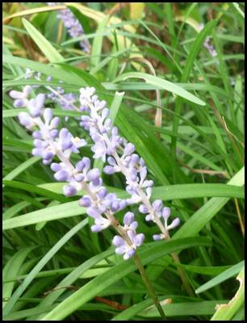
Lovely Liriope- Lilyturf Grass
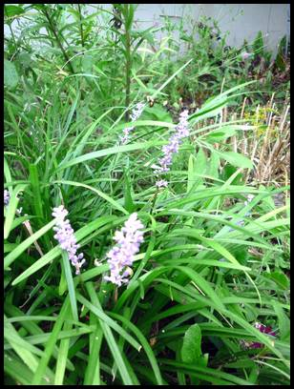

Lilyturf – Liriope spicata and its late season flowers (photos by author)

Lilyturf, or Liriope is a genus that includes a small number of grass-like flowering perennial plants native to East and Southeast Asia. Two of the species, Liriope muscari and Liriope spicata are marginally hardy in our area to about Zone 5a with ‘spicata’ being the hardier of the two species.

Although liriope looks quite a bit like grass producing glossy green arching leaves, it's actually a herbaceous flowering perennial plant in the asparagus family. Different cultivars produce different flowers, with blue, purple or violet colored blossoms. Some cultivars produce berries that stay on the plant through the winter. Connon Nurseries in Ontario offers an interesting cultivar with variegated leaves.

This plant does best in partial shade to shade since in its native habitat in Asia, it grows in shady areas on the tropical forest floor. It does best in average to evenly moist conditions but will tolerate drought when established. It will not tolerate standing water. It is not particular as to soil type or pH. It thrives in warm, humid climates, so our ever-warming humid summers are appreciated by this plant. Lilyturf (liriope) isn’t bothered by rabbits or deer. Lilyturf is very resistant to pests and disease.

The flower spikes of Liriope muscari are taller and showier while the flower spikes of Liriope spicata which tend to hide more within the foliage. The flower spikes can range from 30-46 cm (12-18inches) tall but tend to be a bit shorter in the Moraine garden. The spent blooms form blackish berries. This groundcover does not bloom every year in the Moraine garden. It is a very slow spreader.

Because it is such an iffy perennial for our area, it might be better to start plants from seed to instill a regional hardiness. The plants in the Moraine garden were started this way. The seeds need to be soaked for 24 hours and planted with just a bit of potting mix over the seeds and in a warm spot. It can take a month or more for the seeds to germinate.

If you have any tips, photos, garden stories, questions or information you wish to share or topics you would like covered - please contact our communications coordinator.

